Python Programming Lab Task

Set 3
Q1. Implement a Python class for a stack data structure (`push`, `pop`, `peek`). Use GitHub Copilot to generate code, test its handling of edge cases, and explain any improvements made.
(Each question carries 5 marks)
Prompt: Implement a Python class that represents a Stack data structure with the following methods:
- push(item)
- pop()
- peek()
- is_empty()

code:
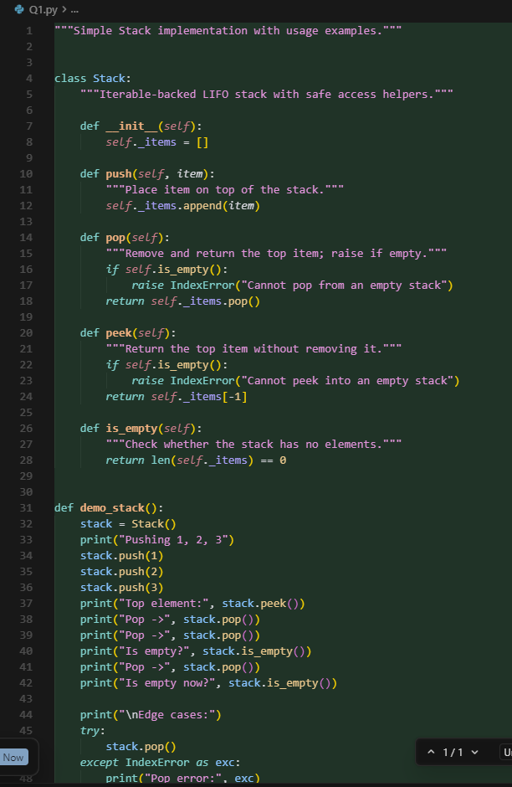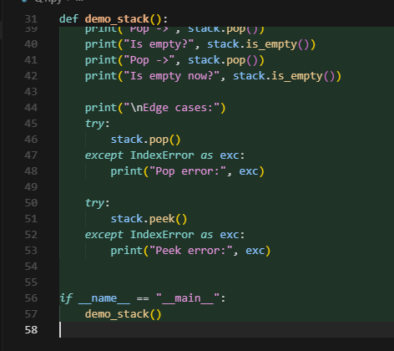

Output:
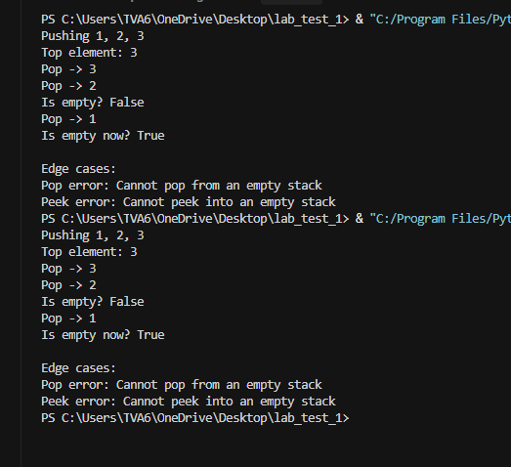

Key improvements:
- Added explicit IndexError messages in pop/peek, so consumers immediately understand why operations fail instead of silently returning sentinel values.
- Wrapped demo edge cases in try/except blocks to show how callers should handle those errors.
- Kept storage in a private list and exposed is_empty as a helper, keeping the API narrow and predictable.

Q2. Refactor a poorly commented Python function using an AI assistant for automatic documentation. Evaluate clarity and completeness versus manual comments.
(Each question carries 5 marks)
Prompt: Refactor the following poorly commented Python function to improve readability and maintainability.
Use AI-generated automatic documentation (docstrings + inline comments where needed).
After refactoring, evaluate:
- Clarity of the AI-generated documentation
- Completeness compared to manually written comments
- Any improvements made in structure, naming, or logic
Code:
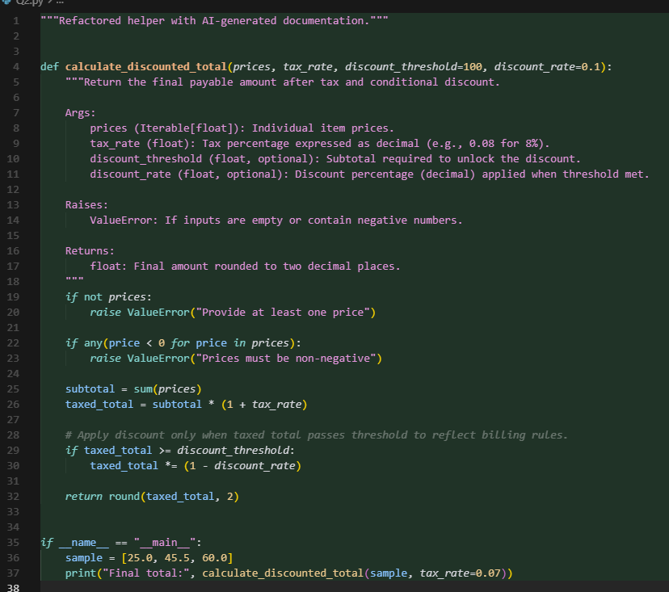

Output:
